|  |
| --- |
| College LaSalle |
| Project - Internet Programming User Manual |
|  |
| Presented to: Mihai Maftei |

|  |
| --- |
| Amritpreet Singh, Amritpreet Singh  12/9/2022 |

The Welcome page

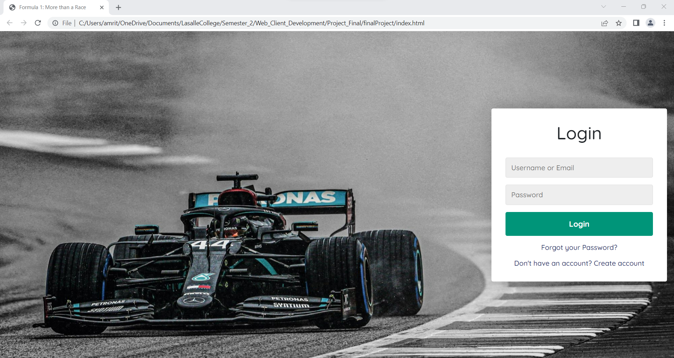

It has few features like when you enter the correct details only they you can access the website.

On click – Login it will verify the details you entered to the one available.

If they match you can access the website.

* If you don’t have an account you click that link which will forward you to page to create an account.

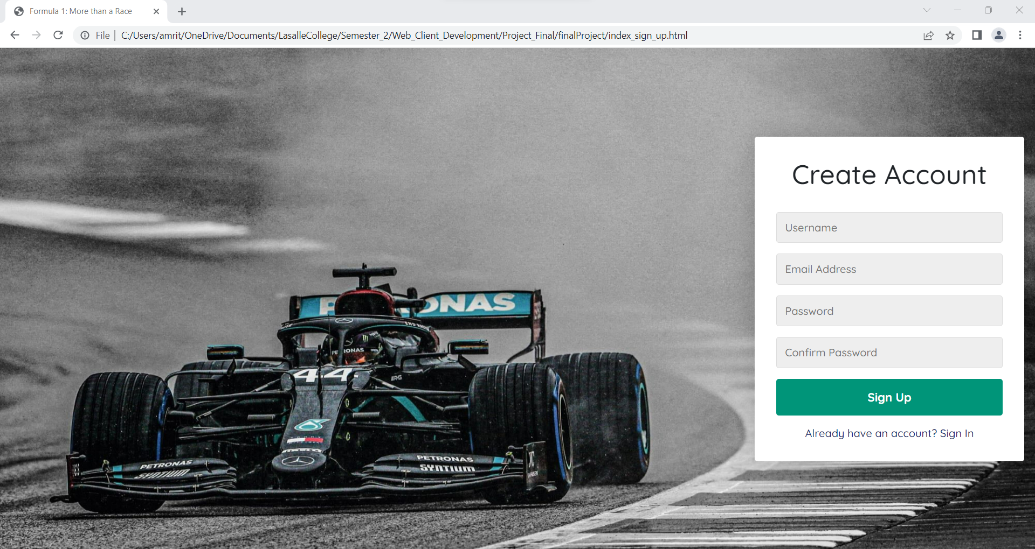

You can also go back to login page from here as well.

Home.html –

Is the main page you get to after logging in

It divided the page into 2 the top section and the content section.

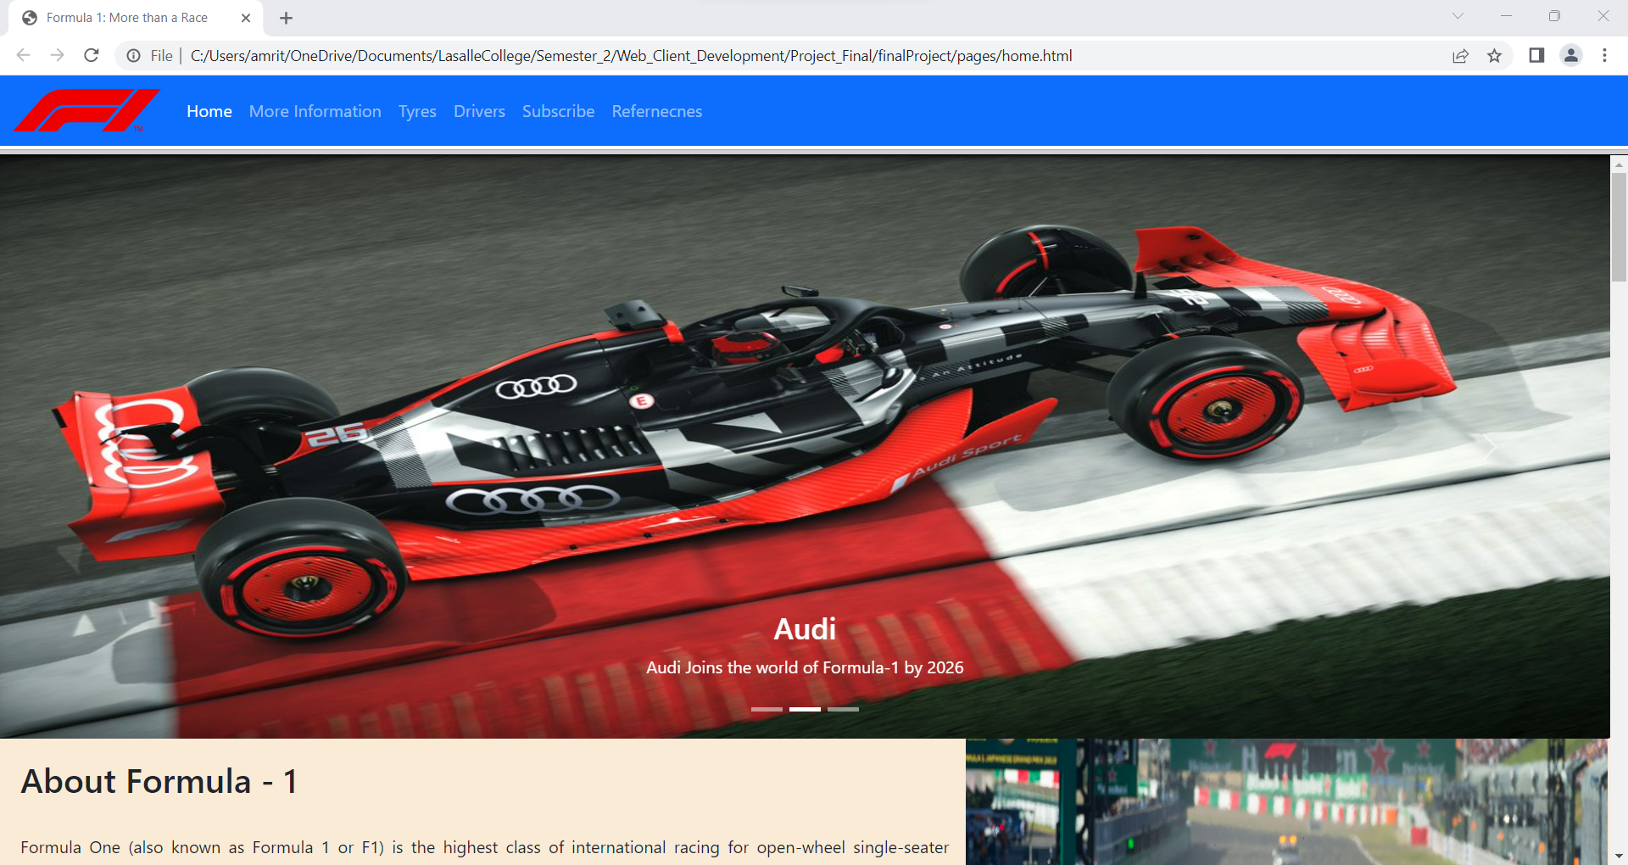

From the menu you can access the different pages available. It has a carousel that display few images and some information.

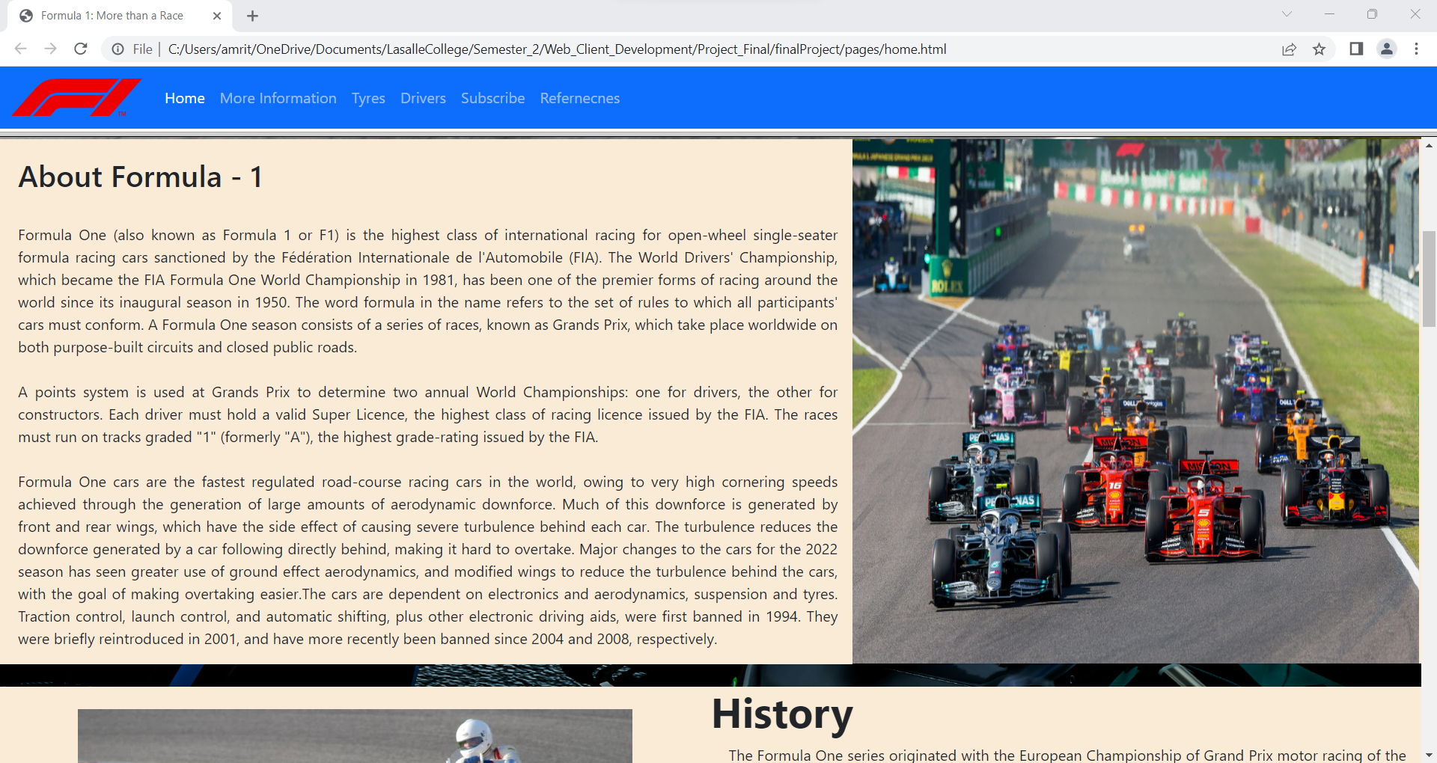

Then there is the some information about the Formula One.

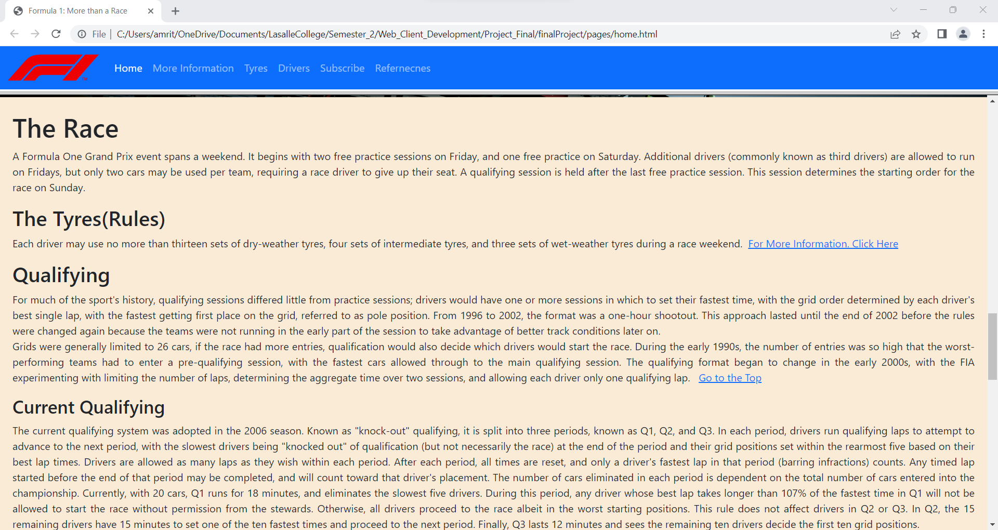

There are some links in here to find some more information.

Or to go back to the top.

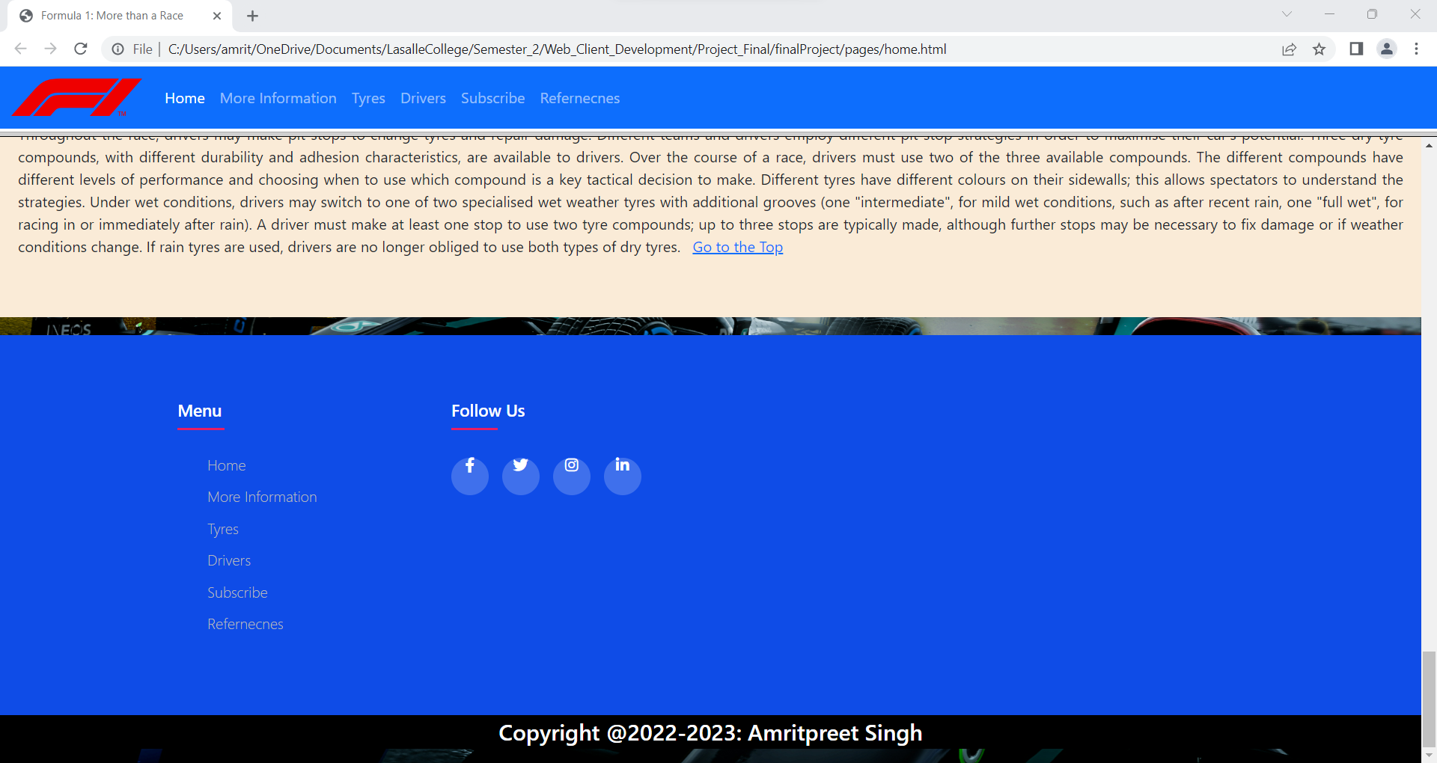

The it’s the footer at the bottom that includes the copyright.

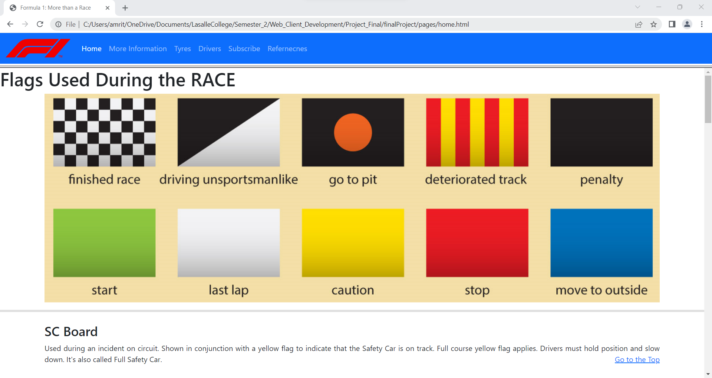

More information about the flags etc.

Flags image uses mapping

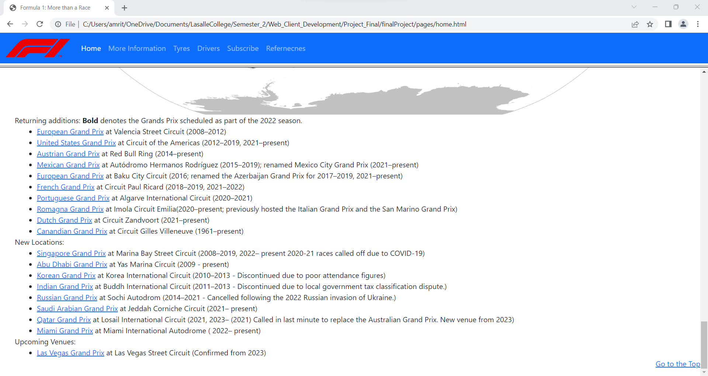

Some external links at the bottom

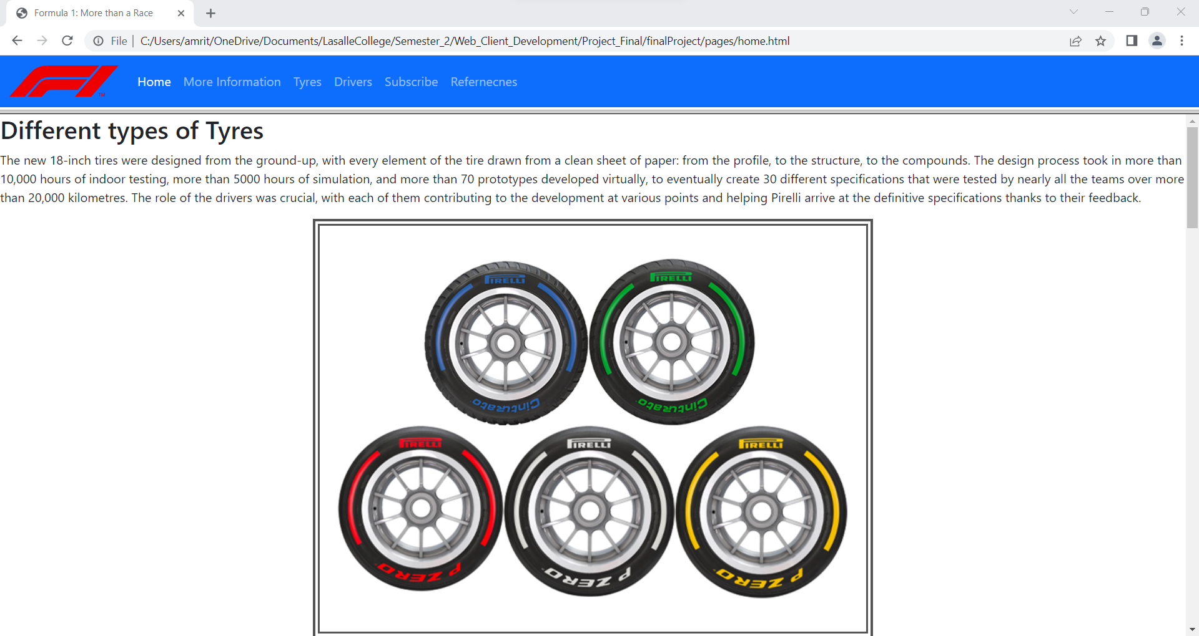

The image uses mapping for more information.

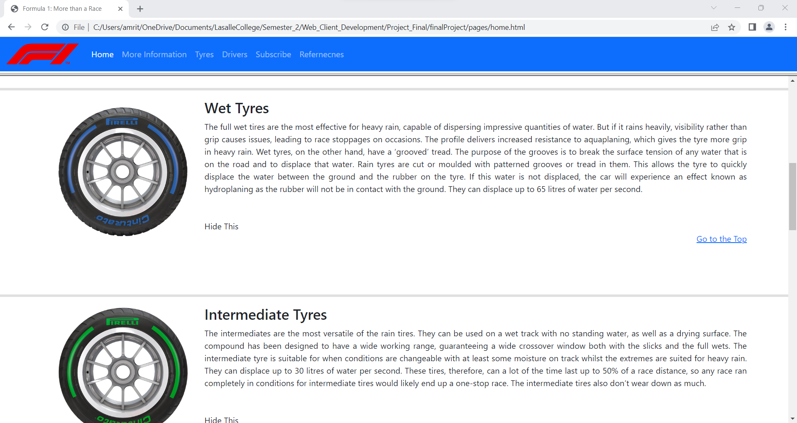

You can click the hide this to hide the information you don’t like

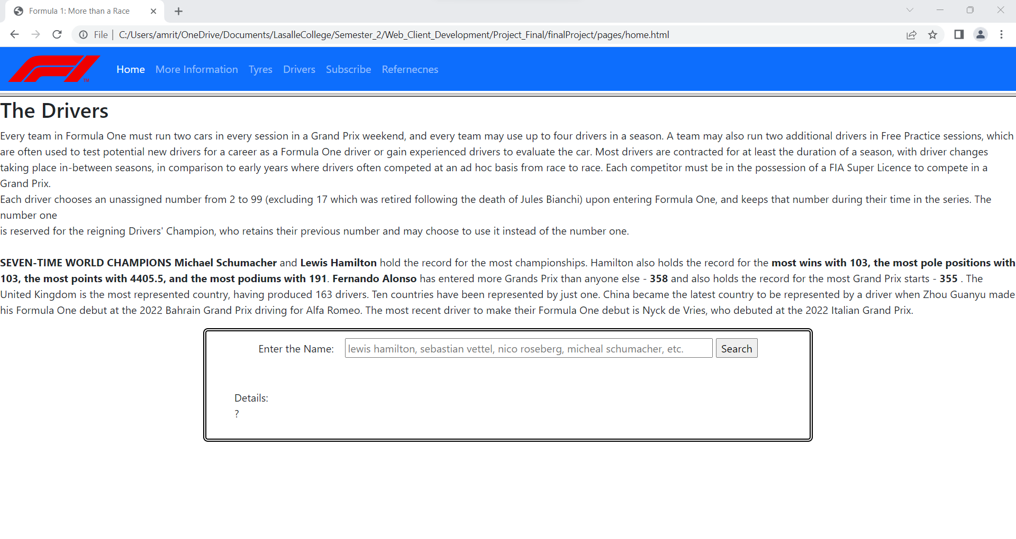

This page has input type search box to search you favourite driver and find more information about them.

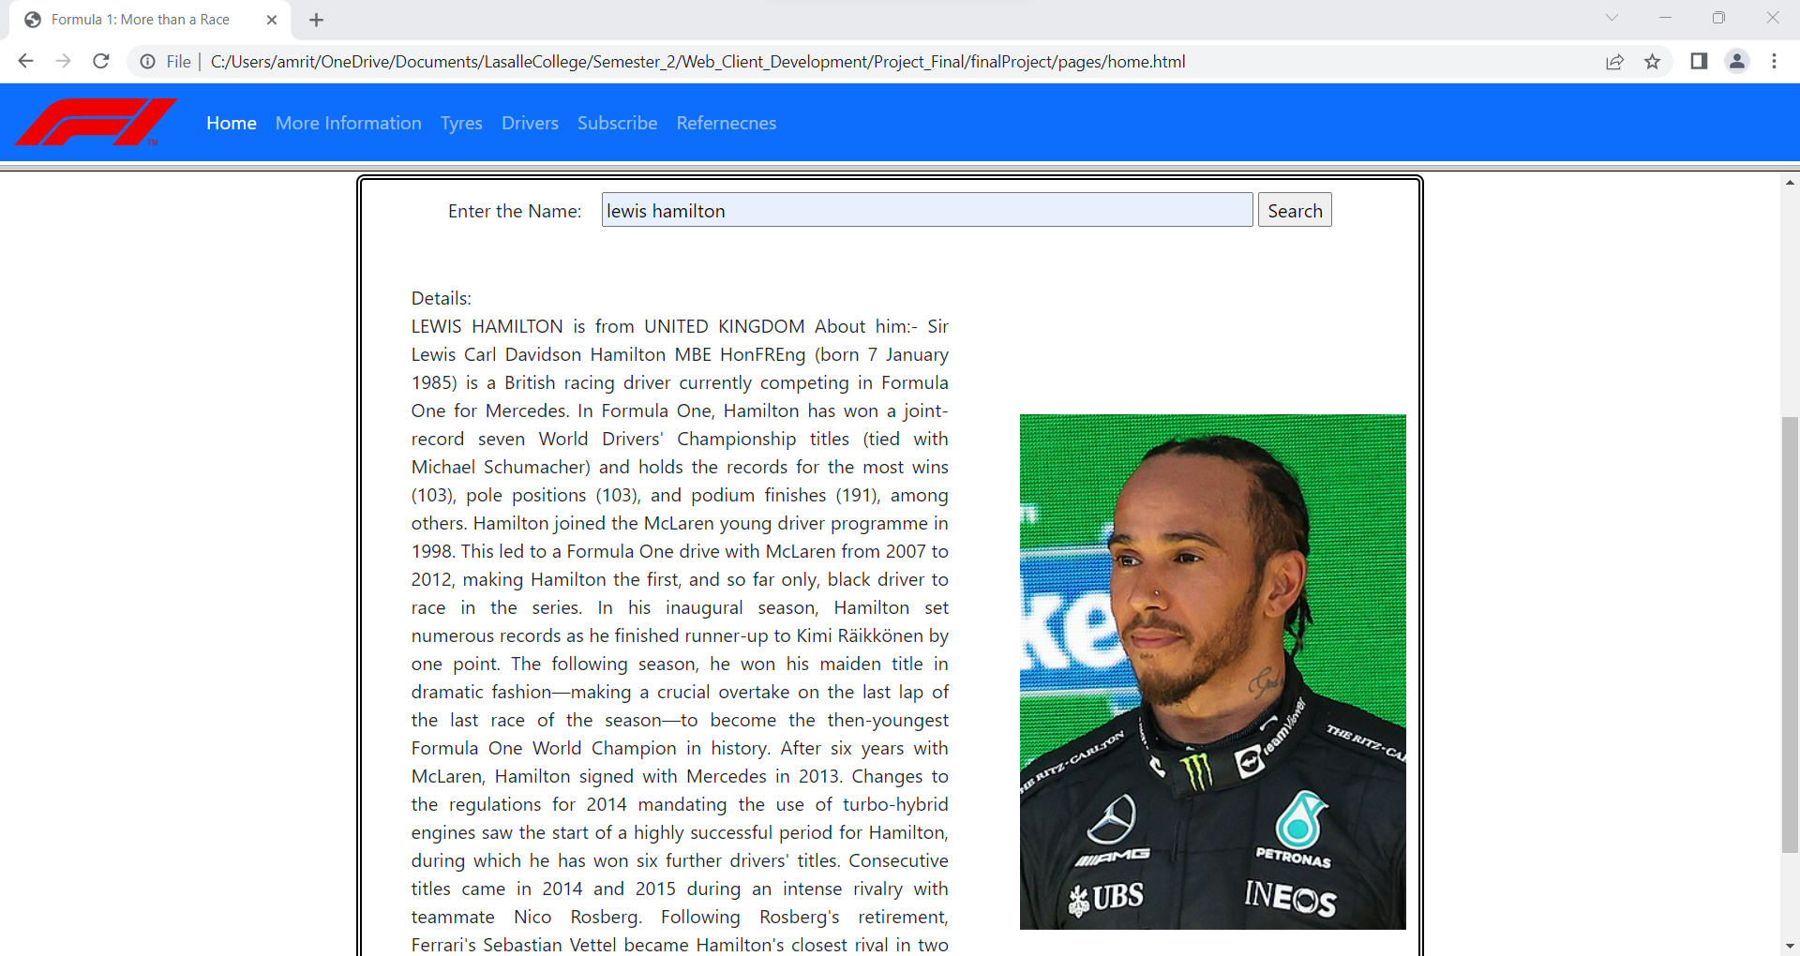

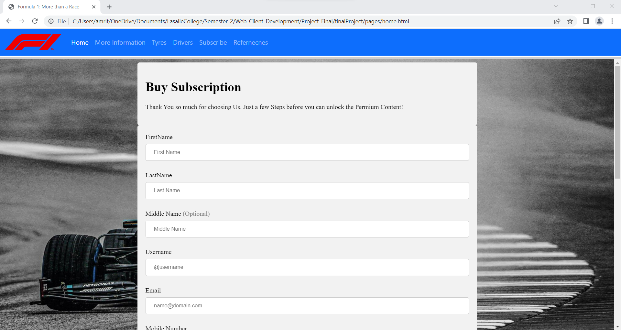

This page has different types of input types and it will tell how much time you spent on this page after you click submit.

Also there are various validations that you have to follow to submit this page

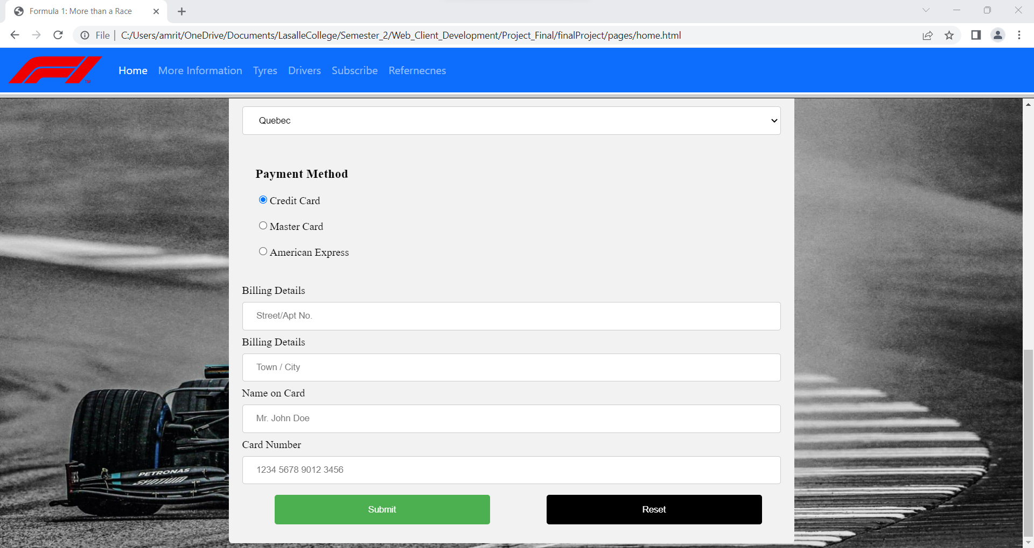

Click reset to reset the whole form and fill from starting.

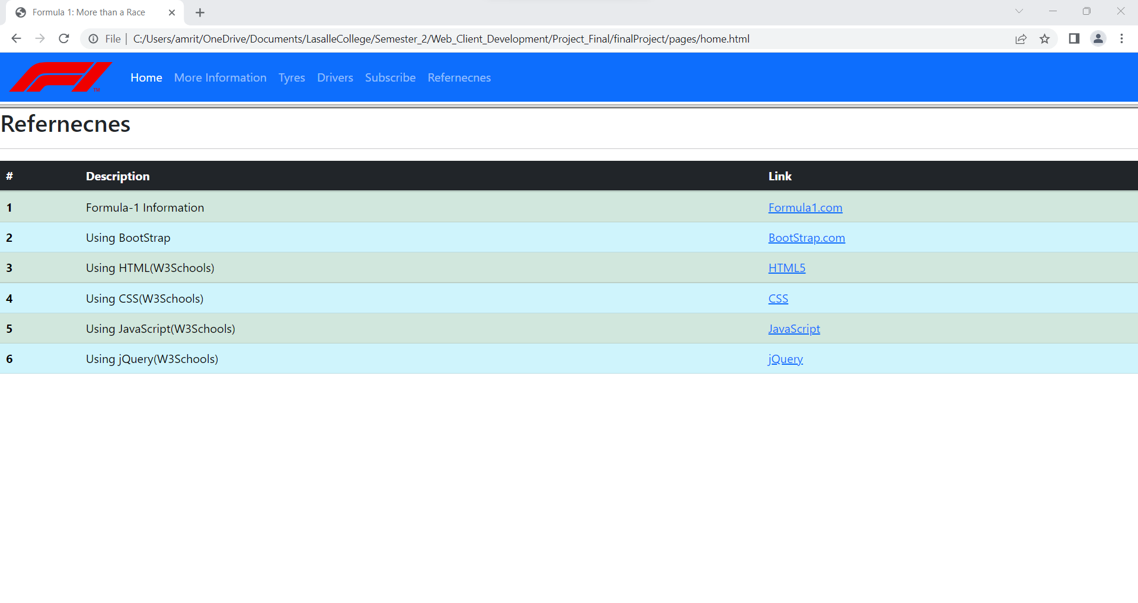

This page includes all the references from where the information was taken. Displayed using tables and links to click.